PDS

Livrable De R4

FOLTETE Ludovic

Manuel utilisateur :

First of all, u have to identify in the application.

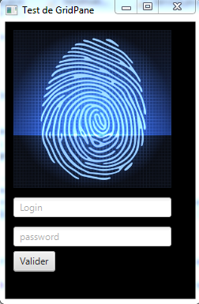

Then, the places are automatically allocate to each shop !  
If you want modify this allocation manually, you can do it with the keyboarding of SQL’s requests in the high screen of the application.

